Final Project Report

AutoEase: Future Genius LMS



Project Supervisor
Mr. Abdullah Qamar

Submitted By

S25PROJECT44E74
Ayesha BC190410098
Ayesha BiBi BC210403598

Software Projects & Research Section,
Department of Computer Sciences,
Virtual University of Pakistan


CERTIFICATE

This is to certify that Ayesha, Ayesha BiBi (BC190410098, BC210403598) have worked on and completed their Software Project at Software & Research Projects Section, Department of Computer Sciences, Virtual University of Pakistan in partial fulfillment of the requirement for the degree of Bachelor in Information Technology, Bachelor in Computer Science under my guidance and supervision.

In our opinion, it is satisfactory and up to the mark and therefore fulfills the requirements of Bachelor in Information Technology.

Supervisor / Internal Examiner

Mr. Abdullah Qamar
Supervisor,
Software Projects & Research Section,
Department of Computer Sciences
Virtual University of Pakistan

___________________
(Signature)

External Examiner/Subject Specialist
<<External Supervisor Name>>

___________________
(Signature)

Accepted By:

(For office use)

EXORDIUM

In the name of Allah, the Compassionate, the Merciful.

Praise be to Allah, Lord of Creation,
The Compassionate, the Merciful,
King of Judgment-day!

You alone we worship, and to You alone we pray for help,
Guide us to the straight path

The path of those who You have favored,

Not of those who have incurred Your wrath,
Nor of those who have gone astray.

DEDICATION


IN THE NAME OF ALLAH THE MOST BENIFICIENT THE MERCIFUL

I dedicate this Project to my beloved
Father & Teachers
And
To the Loving memory of my mother
And also
To my brothers & sisters.
You have successfully made me the person I am becoming
You will always be remembered.
ACKNOWLEDGEMENT
Foremost, I am highly grateful to Allah for His blessing that continue to flow into my life, and because of You, I made this through against all odds.

With a great pleasure I would like to acknowledge the support, assistances and contribution made by individuals from the beginning of the Project, providing me access, data and information, to the writing process until the completion of this project.
First of all, I want to give thanks to our project supervisors Mr. Abdullah Qamar for the access and assistance in order to make my project possible.
Second, I would like to thank all the Mater program staff, thank you all for the assistance and constructive discussions we had during the entire courses

PREFACE

This project report has been prepared in fulfillment of the requirements for the Bachelor of Information Technology in the academic year 2025-2026.

For preparing of the project report, I have closely studied the An online Virtual Study Group Platform
of certain compounds to get the knowledge of the data requirements that will be used successfully to protect any entrance breaches.

I have also studied the software that was required for this project coding like, PHP and databases.

This project started with to test phases I which have given me the ability to understand the concept of programming and move me forward smoothly.

I am very thankful to my supervisors who have helped me to complete this project and I really appreciate all his efforts and support.

I am also very thankful to Virtual University, Pakistan and all the staff.
TABLE OF CONTENTS

CHAPTER NO. 1
gathering & Analyzing info 9

1.1 Introduction………………………………………………………10

1.2 purpose……………………………………………………………..10

1.3 scope ………………………………………………………………..10

1.4 definitions, acronyms and abbreviations……………….…..11

1.5 Project requirements…………………………………………..11

1.5.1 Functional Requirements…………………………………..…..11

1.5.2 Non-Functional Requirements……………………………..…..12

1.6 use cases and usage scenarios …………………………….…..13

1.6.1 Use Case Diagrams……………………………………………..13

1.6.2 Usage Scenarios…………………………………………….…..14

1.7 Development Methodology……………………………..……..21

1.7.1 Chosen Methodology…………………………………………...21

1.7.2 Reasons for Chosen Methodology……………………….……..21
1.7.2 Work Plan (Gantt Chart) …………………………………..…..25
1.7.2 Project Schedule (Submission Calendar) ……………….……..25

CHAPTER NO. 2
designing the project 26

2.1 Introduction……………………………………………..………..27

2.2 purpose……………………………………………….…………....27
2.3 scope ………………………………………………………………..27
2.4 definitions, acronyms and abbreviations…………………....27

2.5 Architectural Representation (Architecture Diagram) ...28

2.6 Dynamic Model: Sequence Diagrams……………………..…..29

2.7 Object Model/Logical Model: Class Diagram……………..38

2.8 Database Model (Database Diagram) …………………….…..39

2.9 Graphical User Interfaces……………………………….……..39

Chapter no.3
DEvelopment 41
3.1 Development plan (Architecture Diagram) ………………....42

CHAPTER 1
Gathering & Analyzing Info

Introduction
Your final year project involves designing and developing a Learning Management System (LMS) and a functional web application for a company offering STEM and AI coding courses for kids in Pakistan. The company aims to provide children with engaging learning experiences through online instruction (Zoom, Microsoft Teams), in-person sessions, and an advanced LMS platform.
Your project must ensure a seamless, interactive, and secure learning environment while integrating key educational technology features for students, instructors, and parents.
Purpose
To provide organizations with a bespoke, fully-customized learning management system (LMS) that is built around their specific training processes, branding, users and data-control needs — not simply a generic “one-size-fits-all” platform. To enable these organizations to deploy training, onboarding, compliance, induction and learning-journeys across employees, contractors or partner/supply-chain networks in a scalable, secure, and flexible environment. To help reduce training & support costs, centralize content delivery and user-management, and provide detailed analytics/reporting to track learning outcomes and help derive business value from training activities.
Scope
The main scope of Future LMS is to provide a fully-customizable, organization-owned learning management system that supports course creation, user onboarding, tracking, engagement, branding and scalability — so training and development (including compliance, partner networks and supply chains) can be managed end-to-end from a system tailored to the business.
Definitions, Acronyms and Abbreviations

Terms | Definition
Web Programming/System | Book Recommender System
SRS | Software Requirement Specifications
VU | Virtual University of Pakistan
Deliverables | These are the documents prepared during development life cycle of the SW project
GUI | Graphical User Interface
MySQL | A type of database management system
PW | Password
SW | Software

Project requirements
  - Functional Requirements

User Roles & Authentication
- Admin Panel: Manage content, users, and analytics.
- Instructor Dashboard: Upload courses, monitor student progress.
- Student Dashboard: Access courses, track progress, complete assignments.
- Parent Portal: Monitor child’s learning progress.
- User Authentication: Sign-up/login via email, phone, or social media.

Course Management & Interactive Learning Features
- Course Creation & Management: Create, edit, delete courses; assign difficulty levels (Beginner, Intermediate, Advanced).
- Quizzes & Assessments: MCQs, coding challenges, and subjective questions.
- Gamification: Points, badges, and leaderboards for engagement.
- SCORM/xAPI Integration: Ensure compatibility for tracking learning experiences.

Payment & Subscription
- Free & Paid Courses
- Subscription Plans: Monthly/Yearly access.
- Payment Gateway Integration

Company Portfolio & Blog
- Showcase training programs, achievements, and student success stories.
- Provide an overview of the LMS and its functionalities.

  - Non-Functional requirements:
- Security:
This application will be secure. This site provides an easy way for you to find diagnostic center that meet your needs. Security has been built into the project and we guarantee it.

- Usability:
User friendly interface will be provided so that user can interact easily. The Diagnostic Center Finder helps you find the right lab to suit your needs by walking you through a few easy steps.
- Responsive:
This application will be responsive. It will look good on all devices like PC, Tablets and Mobile Phones.

- Reliability:
This application will consistently perform the specified functions without failure. If failure occurs, the application will display an error message showing the root cause of the failure.

- Availability:
This application will be able to function during normal operating times.

- Efficiency:
Response time will be quick. It will use very less storage and computational resources.

- Maintainability:
This application will be easy to maintain because it will be built in good architecture and using well coding techniques.

- Portability:
This application will be portable on any platform due to the nature of the web.

- Confidentiality:
This application will protect sensitive data and allows only authorized access to data. General Information just only for unregistered users.

Use Case Diagrams

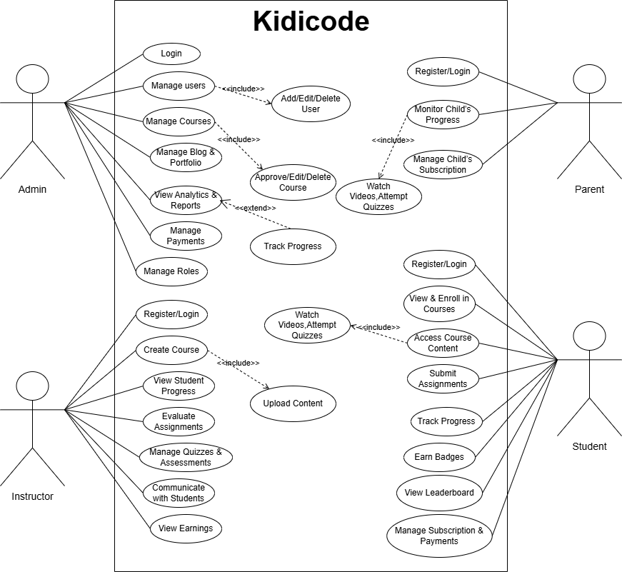

- Usage Scenarios:

Use Case Title | Register
Actor | Student, Teacher, Parents
Use Case ID | 1
Actions | This use case is for Register.
Description | - Brows the application  - View the side bar  - Click the registration button  - Fill the Form with necessary Details
Alternative Path | If Email already exist display Error
Pre-Condition | When the app is running then this app show the nav bar
Post Condition | User Fill the form and new data save into Database
Author | (BC190410098,BC210403598)
Exceptions | N/A

Use Case Title | Login
Actor | Admin, Student, Teacher, Parents
Use Case ID | 2
Actions | This use case for Login
Description | - Brows the application  - View the side bar  - Click the Login button  - Fill the login form with email and password
Alternative Path | IF Password or Email Wrong the system display Error message
Pre-Condition | When the app is running then this app display the login button in sidebar
Post Condition | Login the application and display the main page
Author | XYZ
Exceptions | N/A
Use Case Title | View Quiz
Actor | Students
Use Case ID | 3
Actions | This use case is for View Quiz
Description | - Brows the application  - View the side bar  - Click the Quiz button  - All Quiz Display on the app
Alternative Path | If no Quiz show display not yet found
Pre-Condition | Login First Must
Post Condition | N/A
Author | XYZ
Exceptions | N/A

Use Case Title | Upload Assignment
Actor | Students
Use Case ID | 4
Actions | This use case is for Upload Assignment
Description | - Brows the application  - Login it into the app  - View the side bar  - Click the Upload Assignment button  - All Assignment Upload
Alternative Path | N/A
Pre-Condition | Login First Must
Post Condition | Save Assignment Upload
Author | XYZ
Exceptions | N/A

Use Case Title | Submit Quiz
Actor | Students
Use Case ID | 5
Actions | This use case is for Submit Quiz
Description | - Login into system  - All Submit Quiz  - Try Quiz
Alternative Path | N/A
Pre-Condition | N/A
Post Condition | All Data Save
Author | XYZ
Exceptions | N/A

Use Case Title | Add Quiz
Actor | Teacher
Use Case ID | 6
Actions | This use case is for Add all Quiz
Description | - Login into system  - All Quiz Added  - Quiz Details Added
Alternative Path | N/A
Pre-Condition | Login First Must
Post Condition | New Quiz Added. Save into Database.
Author | XYZ
Exceptions | N/A

Use Case Title | Manage User
Actor | Admin
Use Case ID | 7
Actions | This use case is for Manage user
Description | - Login into system  - All user show Which admin Edit or Delete
Alternative Path | Display message no record found
Pre-Condition | Login First Must
Post Condition | Modified record Save into Database.
Author | XYZ
Exceptions | N/A

Use Case Title | Manage Assignment
Actor | teacher
Use Case ID | 8
Actions | This use case is for Manage Assignment
Description | - Login into system  - All Manage Assignment
Alternative Path | N/A
Pre-Condition | Login First Must
Post Condition | Modified record Save into Database.
Author | XYZ
Exceptions | N/A

Use Case Title | Make Question
Actor | teacher
Use Case ID | 8
Actions | This use case is for Manage Question
Description | - Login into system  - All question show  - Question Details Added
Alternative Path | N/A
Pre-Condition | Login First Must
Post Condition | Modified record Save into Database.
Author | XYZ
Exceptions | N/A

Use Case Title | Track Progress
Actor | Parent, Students
Use Case ID | 9
Actions | This use case is for Track Progress
Description | - Login into system  - All order show on the app  - Track Progress
Alternative Path | N/A
Pre-Condition | Login First Must
Post Condition | Modified record Save into Database.
Author | XYZ
Exceptions | N/A

Use Case Title | Logout
Actor | Admin, Parent, Teacher, Logout
Use Case ID | 10
Actions | This use case is for Logout
Description | - Login Must  - View logout button
Alternative Path | N/A
Pre-Condition | Session start
Post Condition | Session End
Author | XYZ
Exceptions | N/A

Development Methodology
Chosen Methodology
Water Fall Model and Spiral Model are two models which are combined to each other and make VU Process Model. It is also called hybrid approach of system development. This Process model takes advantages and minimizes the drawbacks of both approaches. This is a linear model to solve many problems.

Reasons for Chosen Methodology
Following are the basic reasons for choosing VU Process Model for our project.
- Testing is inherent to every phase
- It is an enforced disciplined approach because to having stage development cycle and every phase has defined start and end date.
- It is documentation driven which means documentation is produced at every stage.
- Emphasis on requirement and design before writing code ensure minimal wastage of time and efforts.
- Our project is divided into different phases which we have to complete in sequence and submit to our supervisor.
- If some mistakes are found than he suggest us to correct those mistakes and improve our project.
- This process will be adopted due to its spiral nature.

VU Process Model
VU PROCESS MODEL The adopted methodology is VU Process Model which is a combination of Waterfall and Spiral Model.

STRUCTURE OF VU PROCESS MODEL
It has four phases and which are Gathering and analyzing requirement, planning, analysis and design, development and final report

1. Gathering & Analyzing Requirement: In this phase we gathered information regarding functional and non- functional requirements of our Project and also prepared Use case diagrams to understand Actors and Uses cases of project and develop usages scenario diagrams to understand all those situations which will come across while using this applications
2. Planning Phase: In this phase we adopted methodology to complete the project different Phase also prepared the Schedule using Gant chart to know which phase will be completed in how many days.
3. Analysis and Design Phase: In this phase consist of two design documents. In Design document 1, we will develop the Activity Diagram, Sequence diagrams, Collaboration Diagram, Architecture Design Diagram and DFD diagram. And Design document II we develop the Object model, Class diagram, interface design, database design, test cases, Deployment diagram and Component diagram.
4. Development & Final Project Report: In this phase we will write necessary code for implementation of our application. Coding will be completed in iterations.

Spiral Model:
The spiral model is a risk-driven process model generator for software projects. Based on the unique risk patterns of a given project, the spiral model guides a team to adopt elements of one or more process models, such as waterfall. It combines the idea of iterative development with the systematic, controlled aspects of the waterfall model. It is a combination of iterative development process model and sequential linear development model i.e. the waterfall model with a very high emphasis on risk analysis. It allows incremental releases of the product or incremental refinement through each iteration around the spiral

Diagram of Spiral Model
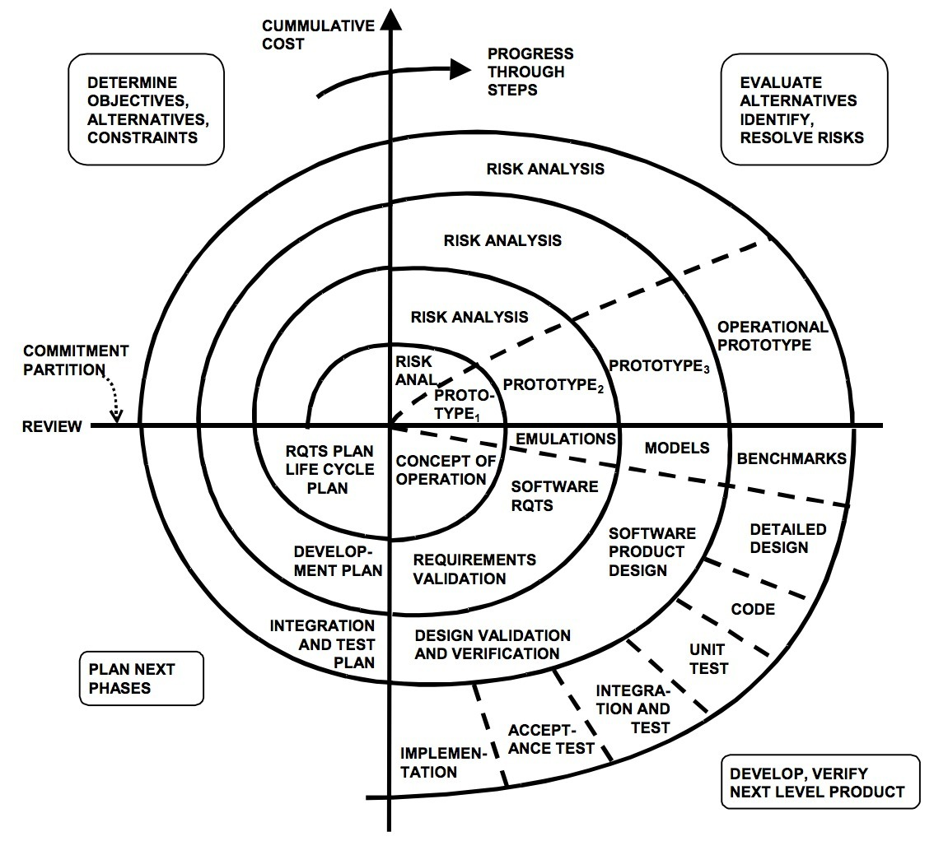

Waterfall Model
The Waterfall Model was the first Process Model to be introduced. It is also referred to as a linear-sequential life cycle model. It illustrates the software development process in a linear sequential flow. It is very simple to understand and use. In a waterfall model, each phase must be completed before the next phase can begin and there is no overlapping in the phases. The Waterfall model is the earliest SDLC approach that was used for software development.
This means that any phase in the development process begins only if the previous phase is complete. In this waterfall model, the phases do not overlap.
The waterfall model is a sequential (non-iterative) design process, used in software development processes, in which progress is seen as flowing steadily downwards (like a waterfall) through the phases of conception, initiation, analysis, design, construction, testing, production/implementation and maintenance. Despite the development of new software development process models, the Waterfall method is still the dominant process model with over a third of software developers still using it.

This model is depicted in the following diagram.

Work Plan:

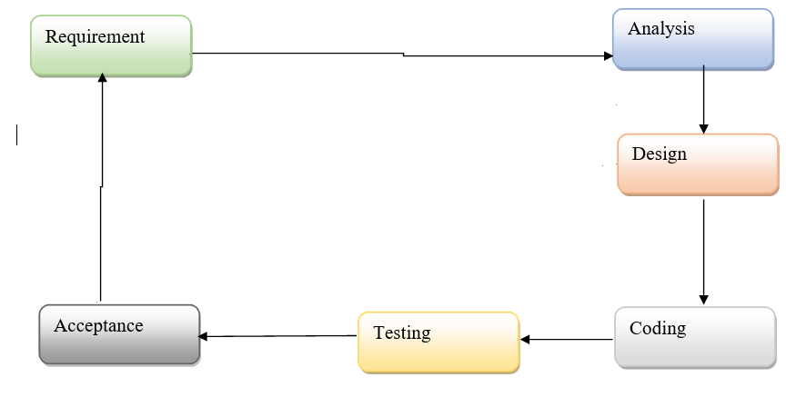

CHAPTER 2
Designing the Project

Introduction
A design document for a final year project serves as a comprehensive guide for the development of the project. It outlines the project's purpose, scope, requirements, and implementation details. The document should provide a clear understanding of the project to the project team, stakeholders, and evaluators. The following are the essential sections that should be included in a design document for a final year project:

- Introduction
The introduction should provide an overview of the project, its goals, and the problem it aims to solve. This section should also include the project's background and motivation.

- Requirements
The requirements section should detail the functional and non-functional requirements of the project. This should include user requirements, system requirements, and any other relevant constraints.

- Architecture
The architecture section should outline the project's high-level design and system architecture. This should include diagrams, such as UML diagrams, that illustrate the system's structure, components, and interactions.

- User Interface
The user interface section should describe the project's user interface design, including user flow diagrams, wireframes, and mockups.

- Implementation
The implementation section should describe the programming languages, frameworks, and tools used to build the system. This should also include any third-party libraries or APIs used in the project.

- Testing
The testing section should detail the testing strategies, including unit tests, integration tests, and system tests. This should also include any automated testing tools used in the project.

- Deployment and Maintenance
The deployment and maintenance section should describe the deployment process, including any required hardware or software configurations. This should also include any maintenance and support plans for the project after its completion.

- Conclusion
The conclusion section should summarize the project's goals, accomplishments, and challenges. This should also include any future work or improvements that could be made to the system.

Definitions, Acronyms and Abbreviations

Terms | Definition
Web Programming/System | Book Recommender System
SRS | Software Requirement Specifications
VU | Virtual University of Pakistan
Deliverables | These are the documents prepared during development life cycle of the SW project
GUI | Graphical User Interface
MySQL | A type of database management system
PW | Password
SW | Software

Architectural Representation (3R- Architecture Diagram)

- Entity Relationship Diagram (ERD) (To be developed using Microsoft Visio or any other drawing software of your choice)
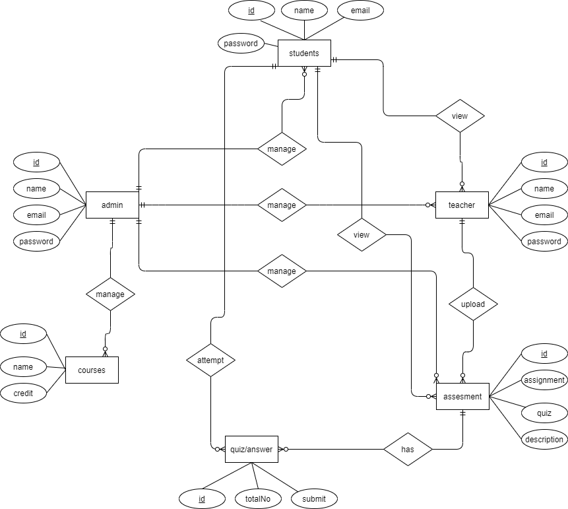
2. Sequence Diagrams (To be developed using Rational Rose or any other drawing software of your choice)

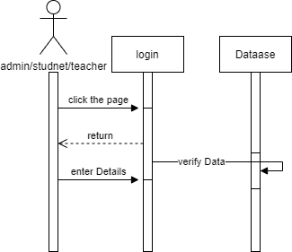

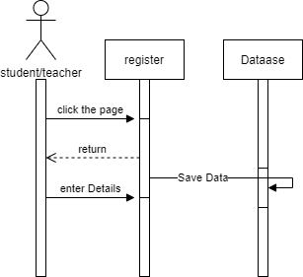
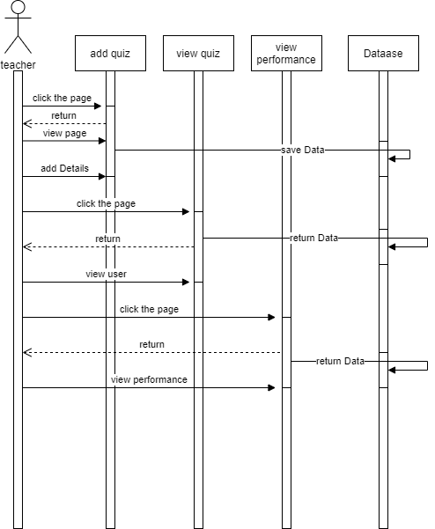
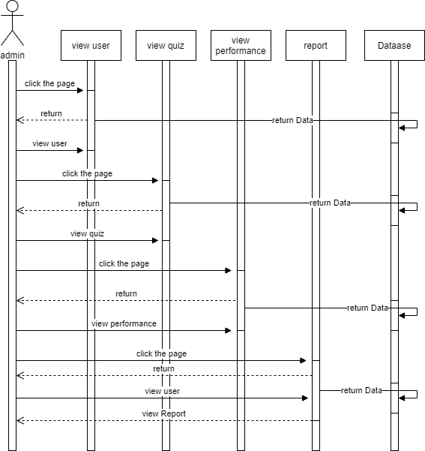

Object Model/Logical Model:
Class Diagram
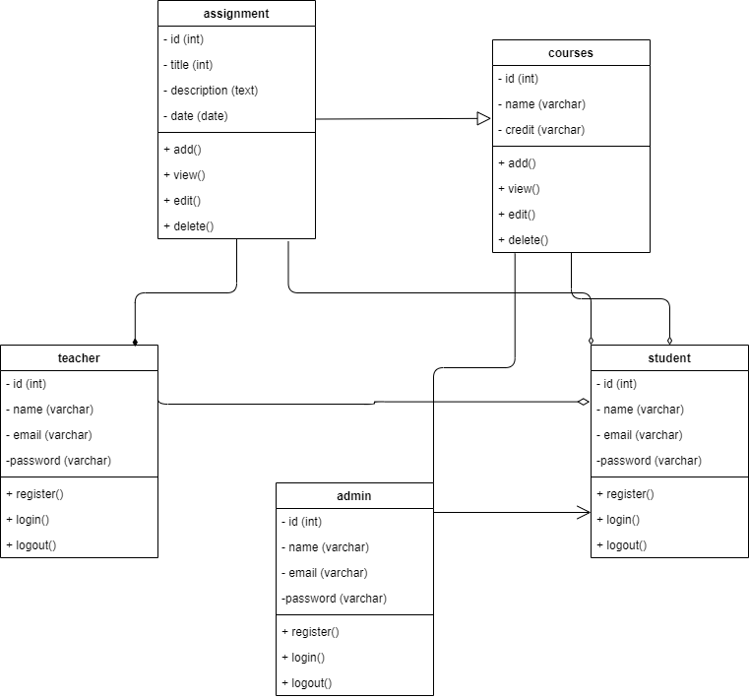

Database Model (Database Diagram)

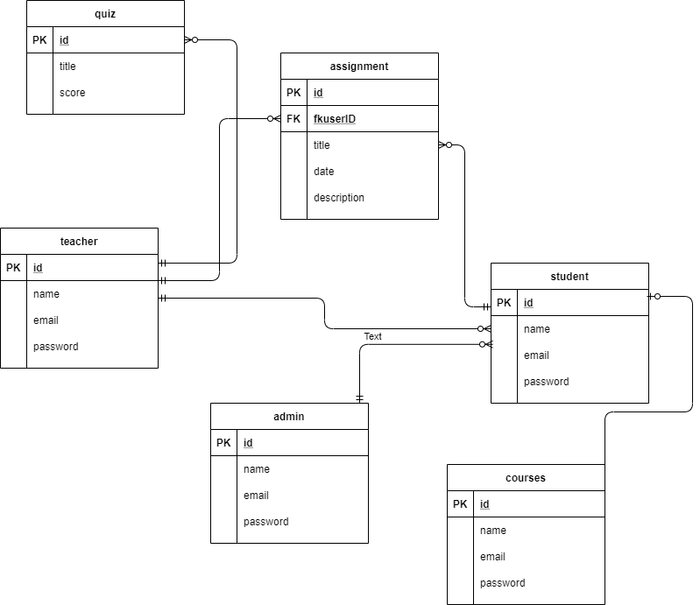

-

CHAPTER 3
Development

Development plan (Architecture Diagram)

REFERENCES

References
In order to develop our system, we have referenced a number of different systems. We have taken help from these systems for removing confusions and to make our system more useful.
However, the major sources were:
[1]. Software Engineering I and II (by Fakhar Lodhi)
This book is studied for different types of testing techniques and design models and Software Engineering Handouts Virtual University of Pakistan
[2]. W3 School (https://www.w3schools.com)
This website helps me in learning HTML, PHP, CSS, BOOTSTRAP.
[3]. Modern Database Management (by Jeffrey A Hoffer)
To understand the different quarries of SQL server for using in our project.
[4]. Principles of Distributed Database System (by M. Tamer Ozsu and Patric Valdary)
We learn different database techniques making database tables and arranging them, form this book.
[5]. Modern Database Systems (By Date C.J) To understand database concepts and managing it using different techniques

APPENDIX

Section 1 | Gathering & Analyzing Info
Section 2 | Designing the Project
Section 3 | Development

